|  |  |  |  |  |  |
| --- | --- | --- | --- | --- | --- |
| Date | 29-Nov-22 | | | Tester Name | Shahabuddin Syed |
| Environment | Penfax - Test | | | Login used |  |
| Operating System | Windows | Version: | Update: | | |
| Software Used | Edge | Version: | Update: | | |
| Select Software | Version: | Update: | | |
| Release version | 22.4.1 | | | | |
| Title |  | | | | |
| Test Type | Regression | | | | |
| Test Scenario | Change an Employee’s Employment Status | | | | |
|  |  | | | | |
| Expected Results |  | | | | |
| Pass/Fail | Pass | | | JIRA# | N/A |

Describe your steps with screenshots:

Need to search for a person in PEPP Penfax5 Test with Marital Status as Married, Plan as PEPP, Member Type as Employee, Member Status as Active, Gender as Male and Employer as "0050"

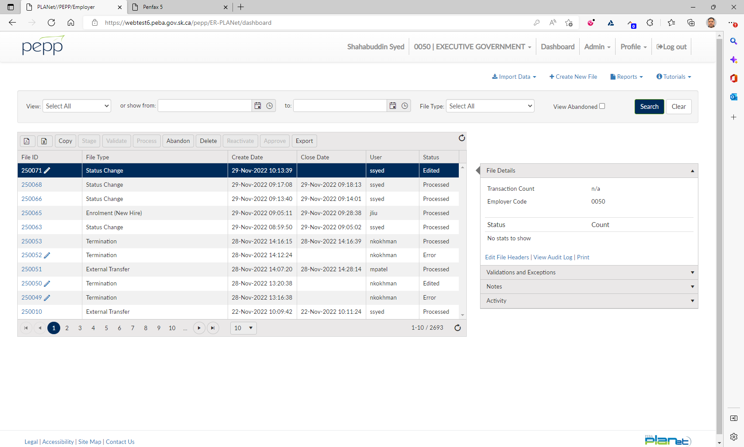

Click on File Type

Select Status change

Click Create

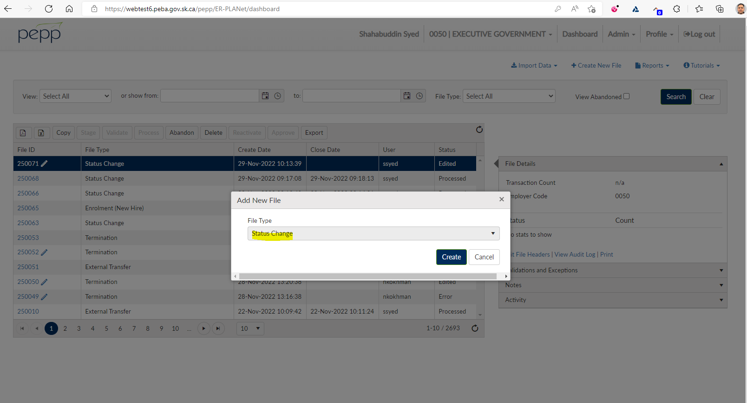

Need to create an entry with proper SIN, lastname, firstname, Event Date, Employment Status,

Employee Type, Province of Employment

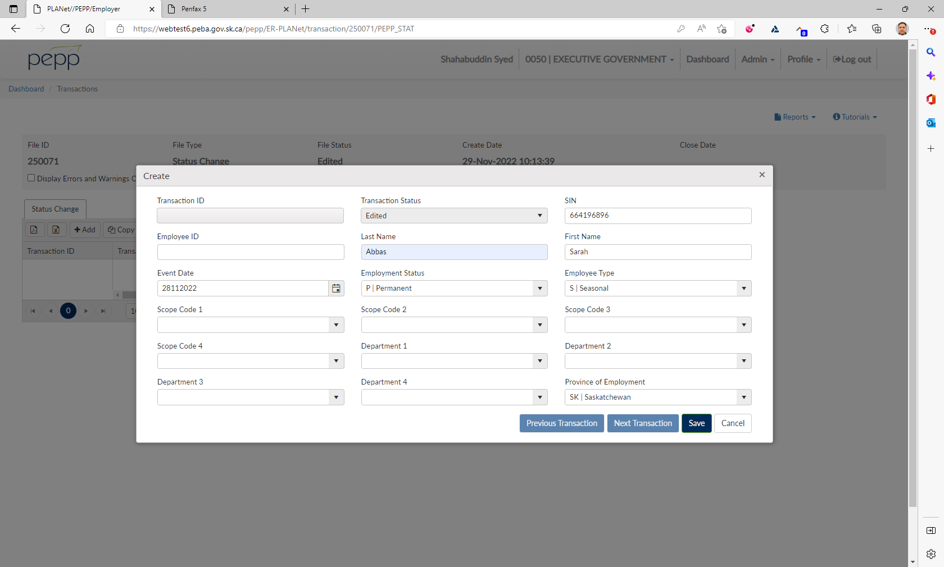

Need to click on Process under File Details

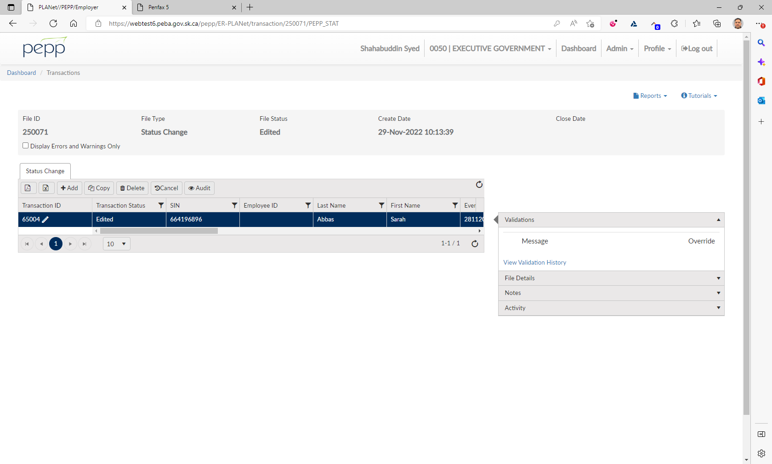

File Status shows as Processed

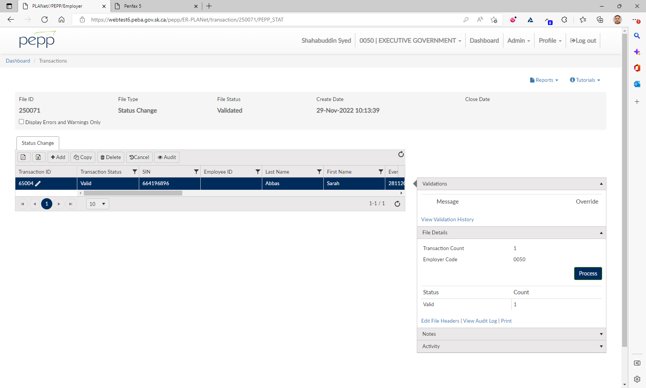

Need to verify in Penfax with the SID

Navigate to Person Profile 🡪 Employment Periods

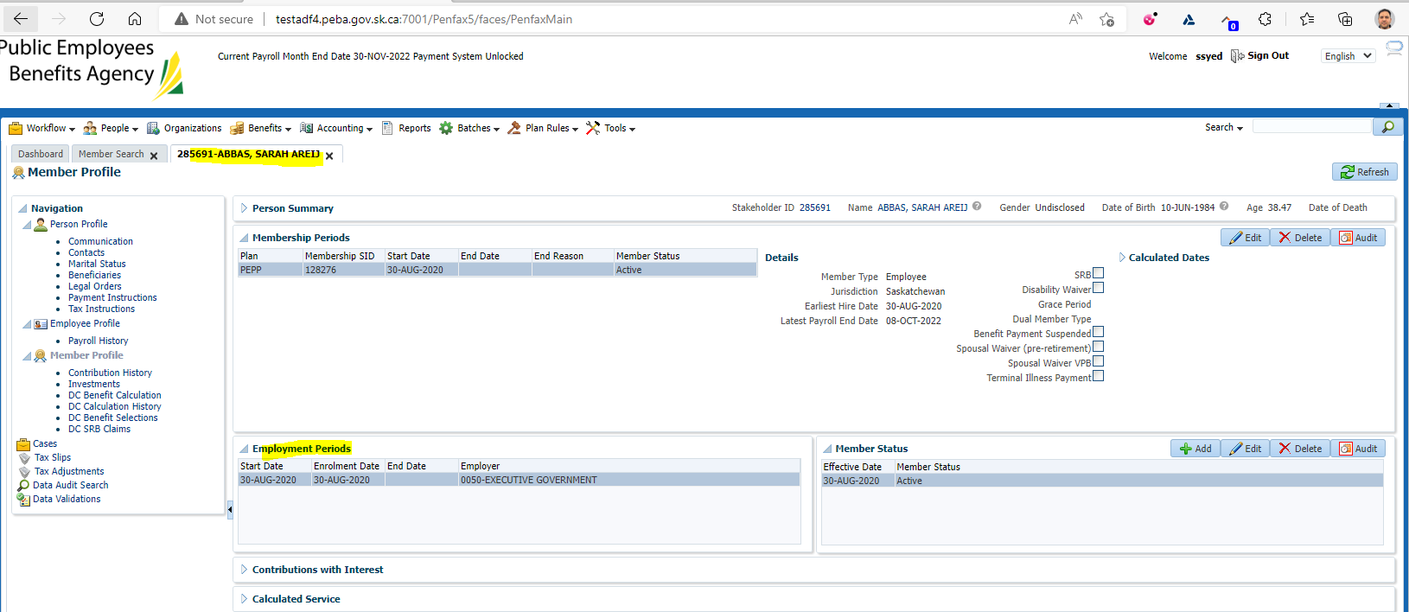

Need to go to Batches 🡪 Data Posting Batch

Status shows as Pending

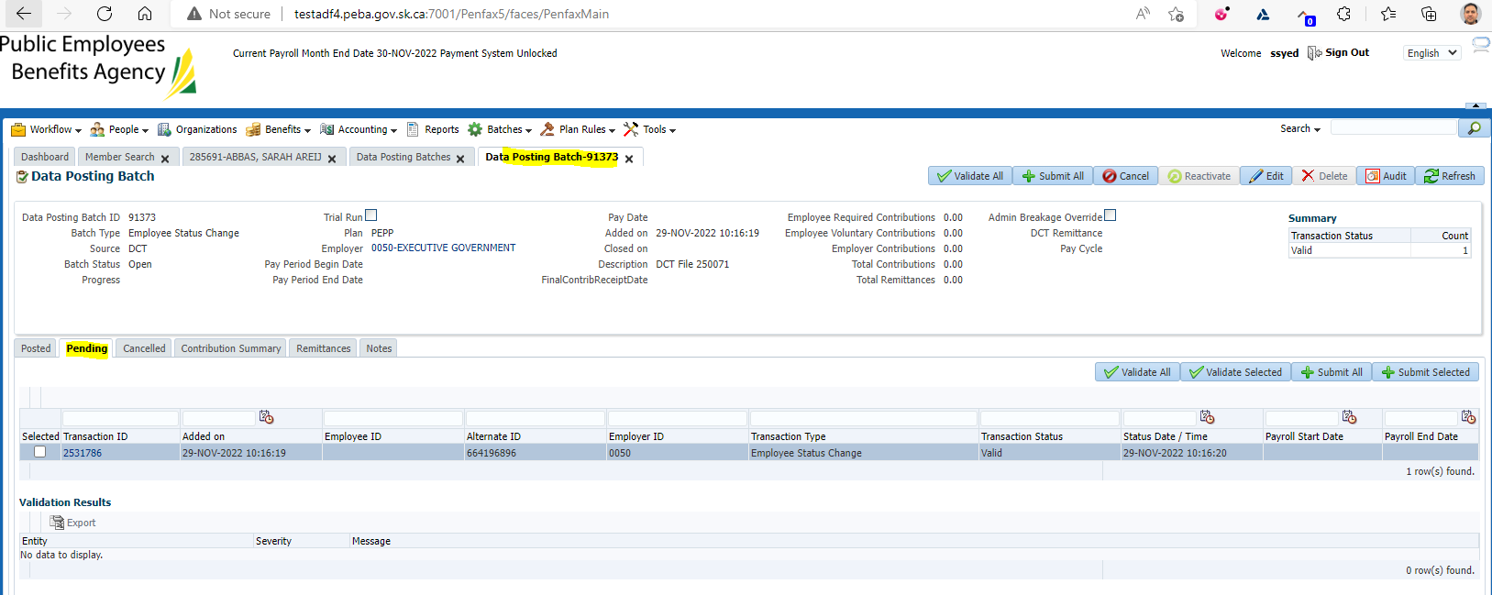

Status changed from Pending to Posted

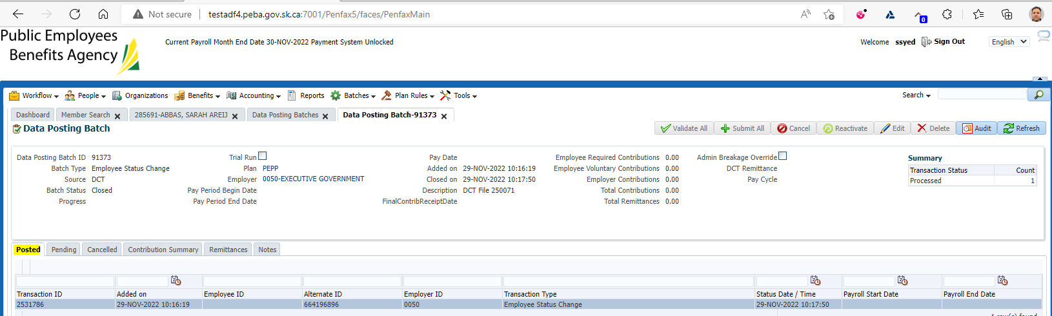

The batch would be posted

To validate the results, it now shows as Posted as it was in Pending status previously

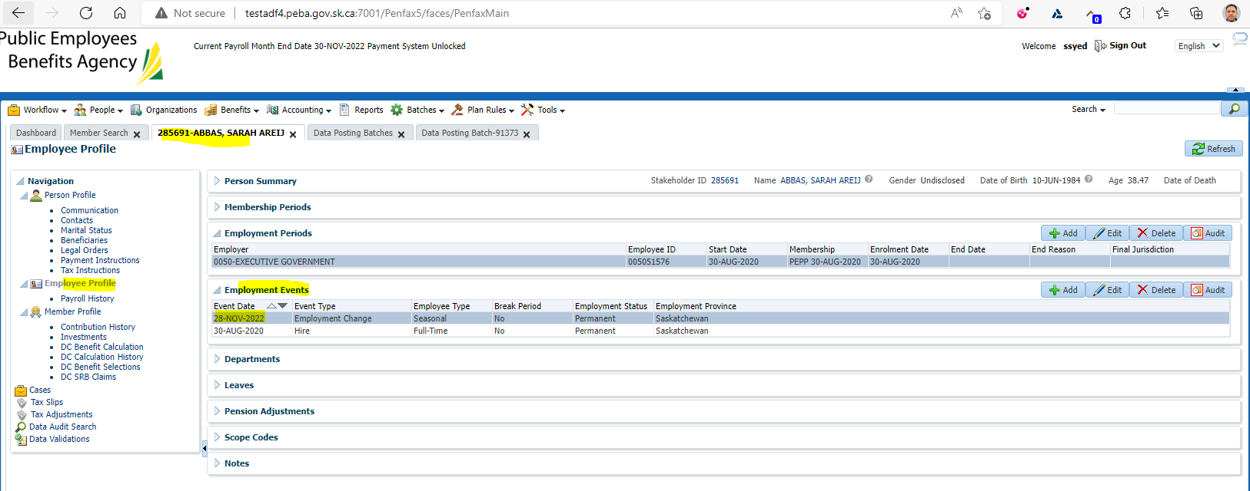

Emplyment Events should have the new line with the changes.

